HMC Hygiene Policy

It is the responsibility of all staff working for HMC and visiting a HMC field or work area to maintain good hygiene standards as fresh produce is being harvested and transported.

- Do not bring any glass or ceramic containers onto a HMC work site
- Smoking is prohibited in all vehicles, on field and in crop areas
- Food and drink must not be consumed within cropping area (includes chewing gum)
- NO PRODUCTS CONTAINING SOYA OR NUTS ON SITE

Make sure you wash your hands regularly using the hand washing facilities provided.

Wash your hands after;

- Using the toilet
- Before preparing food or drinks
- After smoking
- After touching machinery
- Before & after handling crop

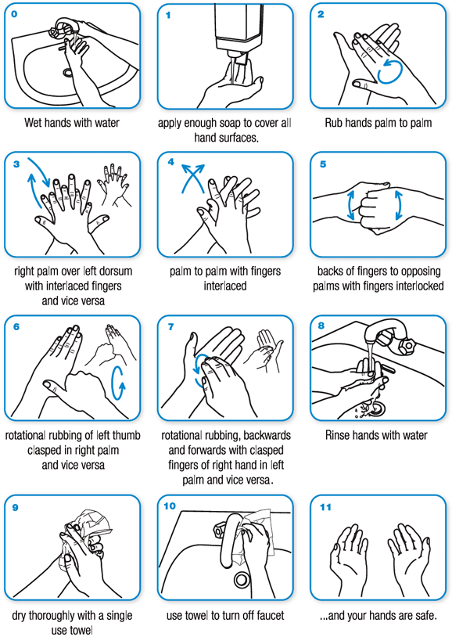

- All harvest personnel to wash hands (with running water and non-perfumed soap) and dry hands before starting work, after breaks and after using toilets
- No jewellery except for a plain wedding band, jewellery used for health reasons or religious jewellery with no stones or jewels
- No rings or studs worn in exposed parts of the body
- No eating, spitting or chewing in cropping areas
- No smoking including e-cigarettes and vaping in cropping areas
- No excessive make-up, false nails, false eyelashes or hair extensions where they present a contamination risk to the crop
- No nail varnish
- No perfume or aftershave

COVID 19

Due to the recent COVID 19 pandemic please follow these steps when working for HMC or on an HMC work site.

- Wash hands regularly

- Maintain a social distance of a minimum of 2 metres from colleagues – if close proximity working is required, face masks and protective gloves must be worn.

- Cough into your elbow

- Sanitise work equipment after use for the next operator with sanitising products provided.

- No more than 2 people in mobile workshop/canteen at a time

- If you are experiencing symptoms of COVID 19 – stay at home and quarantine for recommended government guidelines. Advise shift supervisor.

- If you have come into contact with someone who has COVID 19 advise shift supervisor as soon as possible and quarantine for recommended government timelines.

I read the below documents from HMC and will follow the guidelines they have advised and follow rules set out.

- Hygiene Policy
- COVID-19 Policy
- Health and Safety Policy

Anything you are unsure of please speak to a shift supervisor.

NAME | DATE | SIGNATURE

