SC.c – Signed Food Safety Policy Declaration

Members are required to have a signed food safety policy declaration on record under standard SC.c. The following template can be used for the food safety policy declaration and should be signed by the business owner/ director – being reviewed annually.

Company Name: Holbeach Marsh Co-Operative

Name of owner/ director: Allen Giles (General Manager)
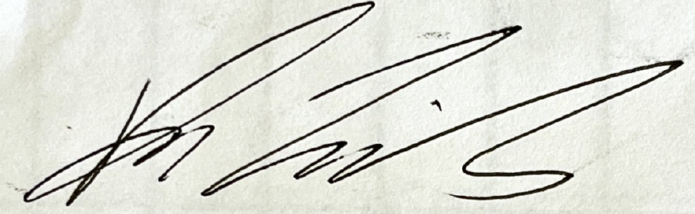

Signature: Date: 08/09/2025

In signing the above, this business is committed to ensuring that food safety controls will be implemented and maintained throughout the production process from planing to product release – these controls will be reviewed annually or after major business changes to ensure relevance and effectiveness.

This is achieved by:

- Compliance and implementation of relevant legislation
- Implementation of good agricultural, food safety and hygiene practices, whilst also conforming to Red Tractor Fresh Produce Standards V.4
- Ensuring all staff have undergone the relevant food safety and hygiene training required for their role, and are monitored to ensure it is implemented

